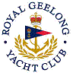 | Royal Geelong Yacht Club Inc.  Est 1859
Trophy Deed of Gift.

Trophy: | Striproll Trophy
Presented by: | Ray Abikhair
Date: | 1986
For: | Winner: VYC Handicap Teams Event. Regatta
Remarks / Revisions | 2006-2007. Reallocated to Last Keel-boat Race of the season.
Click here for a List of Regatta VYC Teams Recipients
Click here for a List of Last Race Winners

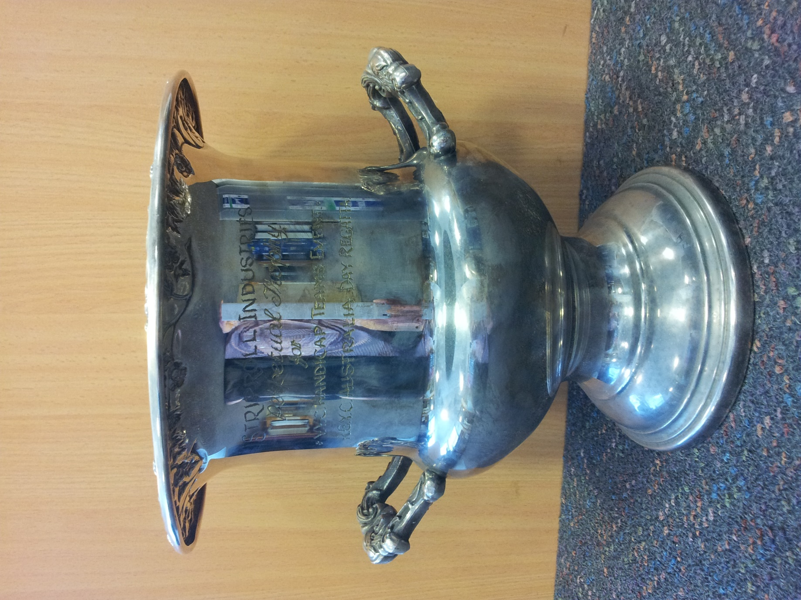

Methodology
- The organising Authority nominates four divisions to be included in the series
- Each Club nominates four boats, one in each division.
- The points scores of the boats representing each club are aggregated for each race.
- Each Club’s score is ranked, smallest to largest
- The rankings then form a club’s per race score.

